EXERCÍCIO 1
Aluno: Felipe Moreira Rios
CURSO: Engenharia de Computação

Quesito 1
Identifique o gênero textual representado nas figuras abaixo.

 A - Caricatura

 B – Propaganda jornalística

 C – Mensagem de Texto



D - Verbete

 E - Charge

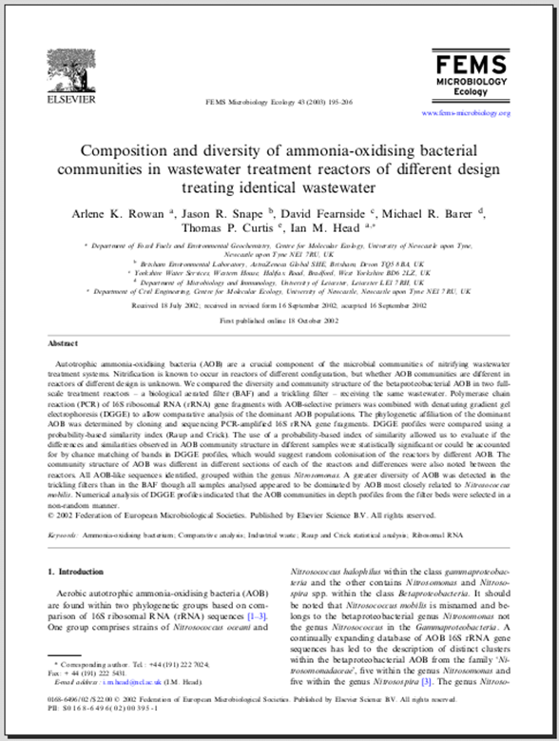

F – Artigo científico

Quesito 2
Complete o texto com as cognatas disponíveis
- VADER is applied to identify suspicious activities from texts posted on social media sites, particularly Facebook and Twitter, to classify sentiments into different categories of positive, negative, and neutral along with obtaining the intensity of emotions.
social categories suspicious intensity

- VADER, a lexicon based sentimental analysis, is utilized to identify the suspicious activities from texts posted on social media sites particularly Facebook and Twitter

posted identify analysis

- Accordingly, it becomes very critical to find out opinion sharing patterns and dig them to exploit the individuals' suspicious behaviors as a social media platform is a haven for these people to communicate with their companions.

platform critical suspicious

- Generally, it aims at processing data into such a form that can be easily used for converting. In this study, Figure 3 show an example of data preprocessing phase undergoes several steps involving.

processing example converting

Quesito 3
Leia o texto abaixo e marque com amarelo as palavras cognatas e com azul as palavras que você conhece de experiências prévias. Se você escreve seus exercícios, sublinhe as cognatas e circule as palavras de experiência prévia.

- On average, accidents per flight hour of occur 100 times more often than with manned aircraft. The main factors of high accident rate are frequent assembly and disassembly of systems, ignoring collection and analysis of information about the nature of component failures, low level of service and personnel qualification.

- This study proposes the use of mathematical method of artificial neural networks for aircraft maintenance. Statistics on the operation of individual components will be used to neural networks learning, and the predicted reliability analysis based on operational and maintenance history data are used as a decision support system (DSS), to provide recommendations for detailed inspections and, if necessary, further repair or maintenance.

- The accuracy of the results is compared with the traditional method of mathematical interpolation. Also, the evaluation of the analysis of the nonlinear factors, the introduction of additional perturbations starts at a specific time. This simulates cumulative factors such as cosmic radiation. This work is a contribution to the promising UAV service models.

